**J Unit Testing Exercises:**

**Exercise 1: Setting u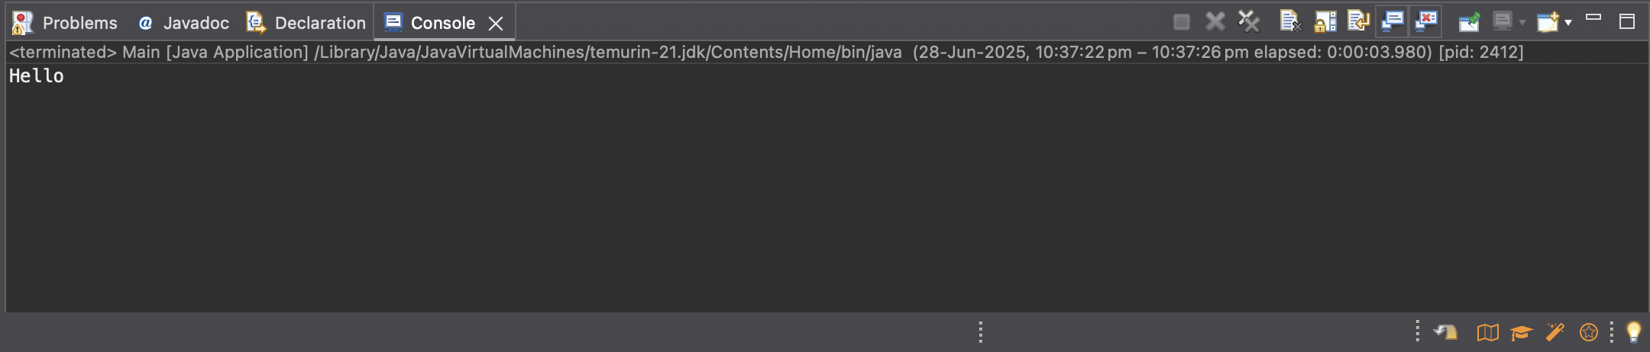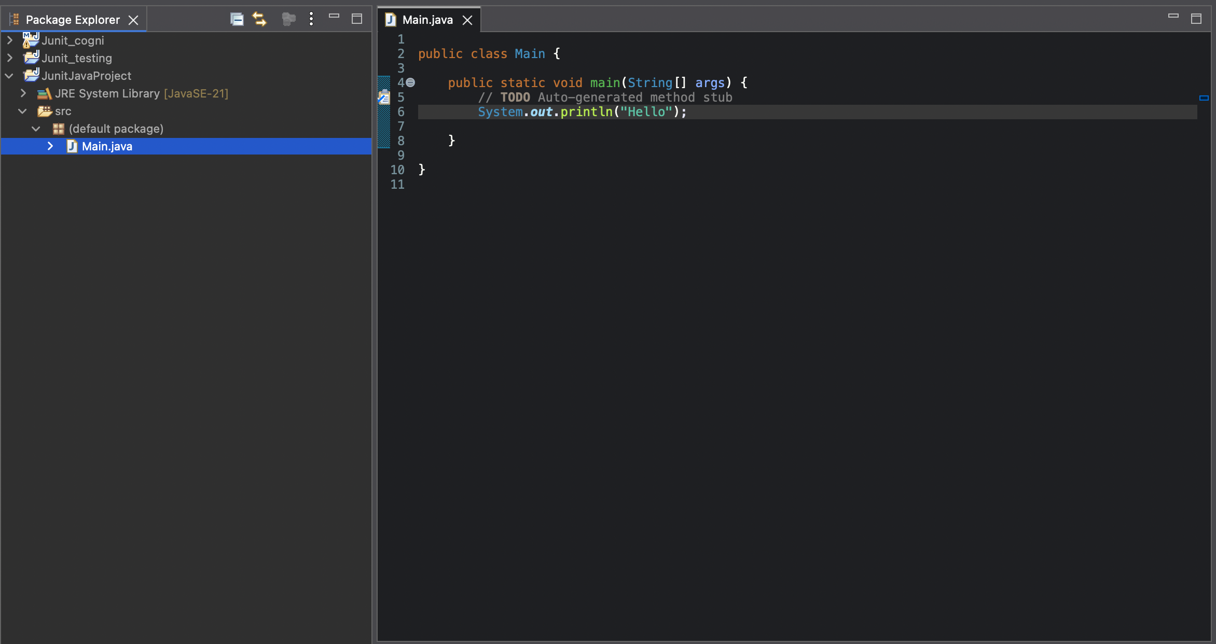p JUnit**

1.Create a new java project:

2. Adding Unit Dependency 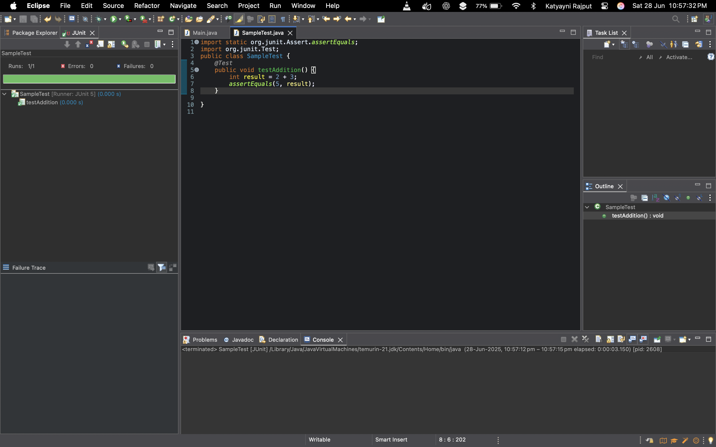and creating a new test class: